
SALARY SLIP
Pay Date: 2/11/2024
Pay Period: Oct 2024

EMP/9095
Mr. Pavan T
UX Designer

PIXLIFY Internet Solutions
303, Block–A, the Platina,
Kothaguda Road,
Gachibowli
Hyderabad-500032

Earnings | Amount
Basic Pay | 12,950.00
HRA | 6,475.00
TA | 1,600.00
Special allowance | 4875.00
Total Pay  Total Pay in Words | INR 25,900.00  Twenty Five Thousand Nine Hundred  INR
PT Deductions | 200

Net Pay  Net Pay in Words | INR 25,700.00  Twenty Five Thousand Seven Hundred  INR

Payment Details
Payment made to employee's bank account.

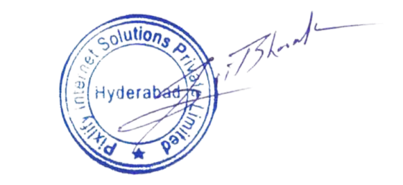

For PIXLIFY Internet Solutions

This is a system generated payslip.

